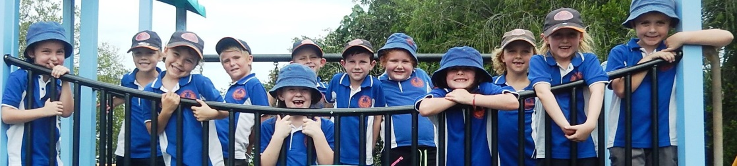
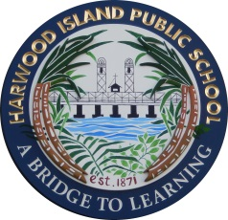
HARWOOD ISLAND PUBLIC SCHOOL
Kindergarten Orientation 2018
For parents and children starting school in 2018
Thursday 26 October 2017
9.00am – 11.30am

Information session and morning tea for parents.
Children will spend the morning in the classroom with the Kindergarten teacher and buddy
Children will need to bring along a sun-safe hat, a piece of fruit for fruit break and something to eat at recess.

Thursday 2 November 2017
9.00am – 11.30am

Children will spend the morning in the classroom with their kindergarten teacher and buddy
Children will need to bring along a sun-safe hat, a piece of fruit for fruit break and something to eat at recess.

Thursday 9 November 2017
9.00am – 11.30am

Children will spend the morning in the classroom with their kindergarten teacher and buddy
Children will need to bring along a sun-safe hat, a piece of fruit for fruit break and something to eat at recess.

Thursday 16 November 2017
9.00am – 11.30am

Children will spend the morning in the classroom with their kindergarten teacher and buddy
Children will need to bring along a sun-safe hat, a piece of fruit for fruit break and something to eat at recess.

Please call into our friendly office for an enrolment package
or phone 66464213 for more information.

